**Mulpha source code manual**

* **1）Installation of Visual Studio Code, node.js and React**

You can check this video between 5:00~10:00 to see how to do the installation.

<https://www.youtube.com/watch?v=Ke90Tje7VS0>

**Node**: <https://nodejs.org/en/download>

After installing the Node.js, open a terminal and type:

*npm install -g create-react-app*

**Visual studio code**: <https://code.visualstudio.com/download>

Please install two extensions for VS code: 1) simple react snippets 2) Prettier

* **2）Check the dashboard**

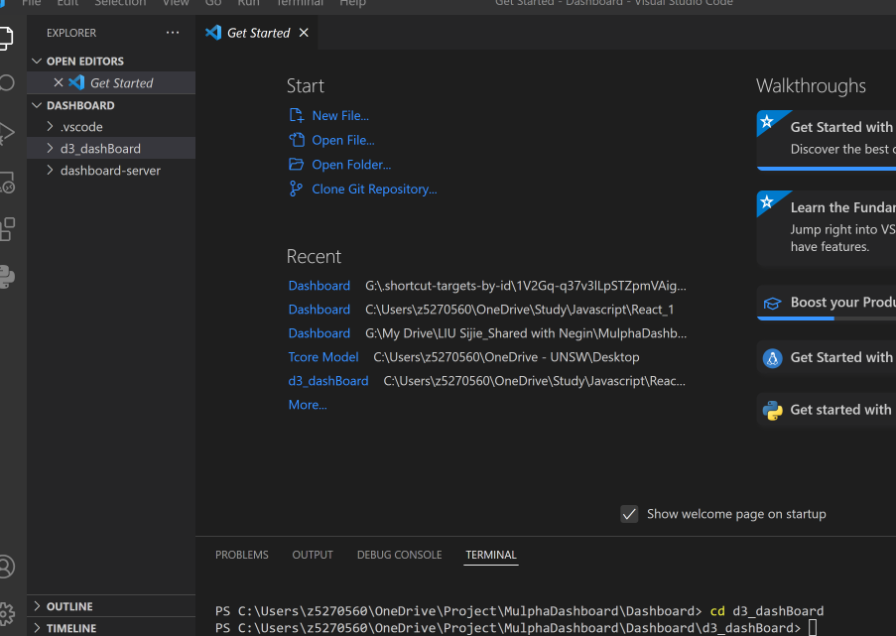

Open the folder in VS code and then type in the terminal to go to the source code folder: *cd d3-dashBoard*

Then type to install all the modules needed for run code: *npm install*

And you will see a screen as shown in the picture, wait until the installation completed.

Then, type in terminal to start the dashboard: *npm start*

And your browser will be opened automatically and take you to a localhost page and you then can check the dashboard in this page. You can type Ctrl+C to terminate the dashboard.

* **3）Directory and the dashboard**

There are two folders under the folder Dashboard: **d3-dashBoard** is used to store all the source code for the webpages and handling the interaction between dashboard and users. **dashboard-server** is to store all the source code for a python backend that is used to calculate the HSI and AQI on the homepage.

**Frontend: d3-dashBoard**

All the components’ source code are stored under the: d3-dashBoard/src.

* **Homepage.js**

|  |  |
| --- | --- |
|  |  |

* **IndexDetails.js**

|  |  |
| --- | --- |
|  |  |

* **StationOverview.js**

|  |  |
| --- | --- |
|  |  |

* **Components**

Also, you can find the components that used for these different pages are stored under the folder src/Components.

1. Components/Data

This folder stored all the components used to extract data from API for dashboard.

1. Components/Overview

This folder stored all the components used for Overview section:

1. Components/Maps

This folder stored all the components for maps and station description.

1. Components/WeatherAndHeat

This folder stores all the components for weather section

1. Components/AQI

This folder stores all the components for AQI section

1. Components/images

This folder stores all the images for dashboard.

1. Components/HistoricalData

This folder stores all the components for historical data section.

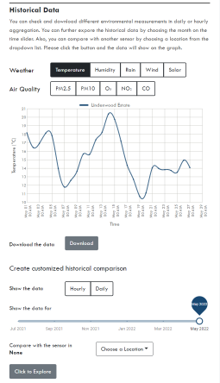

**Backend: dashboard-server**

You can find the python file for calculating heat stress index and air quality index are stored in server1.py

* **4) Deploy the dashboard**

**Deploy the Frontend (Netlify)**

If you update the frontend of the dashboard, please write this code in terminal:

*npm run build*

Then right click the build folder -> reveal file in explorer

*make sure you run this code under the file of frontend.

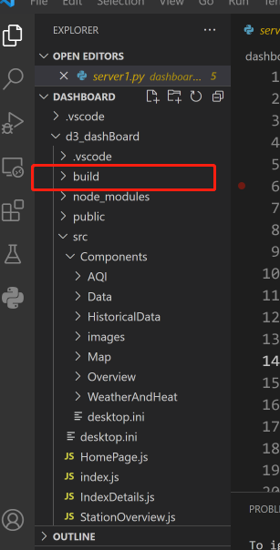

Go to Netlify

<https://www.netlify.com/>

Step 1：Find the mulpha-dashboard project (The name might be changed), click it.

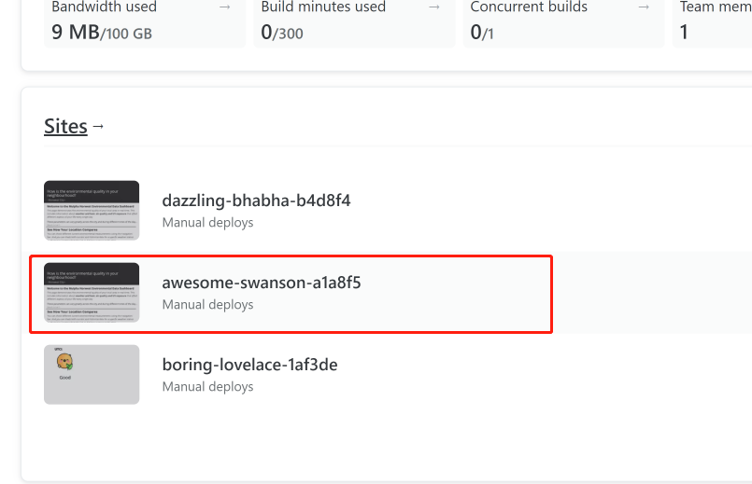

Step 2: Click the deploy in the menu.

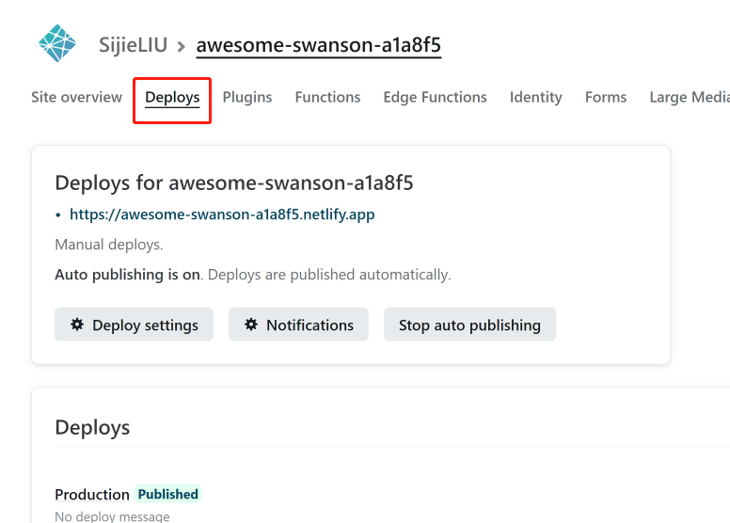

Step 3: Drag and drop the build file to production and done！

**Deploy the Backend (heroku)**

<https://www.heroku.com>

To get a better understanding of how to change the python flask backend and deploy it to Heroku, I highly suggest you watch this video:

<https://www.youtube.com/watch?v=h96KP3JMX7Q>